What is your RMD file doing with the data?
This document will focus on specific items that the RMD or R markdown file is doing with the data that you are extracting from Workday. Follow along and read the information below on the various topics to gain a better understanding of what is happening.

What is a R Chunk?
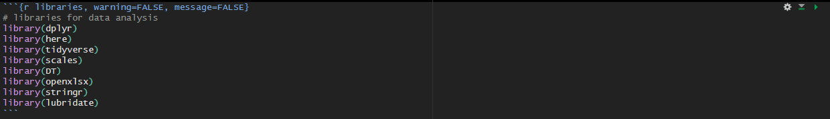
R code chunks can be used as a means render R output into documents or to simply display code for illustration. Here is a simple R code chunk that will result in both the code and it’s output being included:

The chunk begins with ``` {r chunkname} and ends with ```
Place your cursor at the beginning of the line below the ``` {r chunkname} as shown below in the red circle
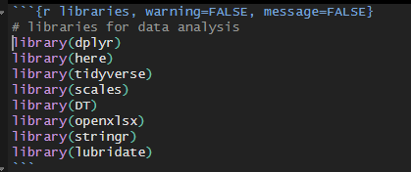

It might be a lighter or darker color on your screen for where the chunk begins and ends. Run everything within the chunk.

Libraries/Packages Chunk
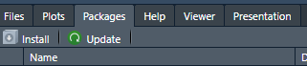
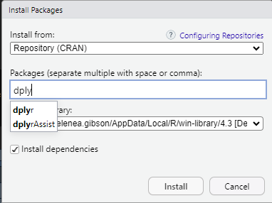
Libraries – It important to read in the libraries before you can start working or else the code will not run. Some of the libraries may not be installed which will resort in an error upon reading. If that is the case, then make sure to install packages using the packages tab at the bottom of the page > click install > type in the package name > and then run it.

Reading in the data Chunk
Read in your data from the folder that contains the data needed to complete the script. You can read in any file extension that R allows for like csv, xlsx, or shp.
Created a data frame or dataset that will house the data that we want as a variable to use for the analysis.

Cleaning data Chunk
It is important to inspect the data that is read into R because it may be read oddly or not the same way that Excel does. For cleaning the data, you can perform multiple steps such as only reading in certain rows, making the column headers or names be a different format type like text, numeric, etc.… You can rename the column names to something that makes more sense to those who will be using the data.
Make sure that NA’s and NULL values are addressed
NA values are often not needed in datasets because you want to have a full dataset with no missing data. There are ways to address these values, and you can take them out in a few steps. An example is (na. rm = TRUE) – meaning that you are excluding na values. You can use (is.na ()) as well.

Monthly amounts match Chunk
Aggregating the ledger data to calculate the monthly spendies dataset. Then we will compare the data frame that was just created to the original data frame.
Next is to apply a filter on the values that do not match the data frame to highlight areas that are of interest to the user. This is another way of double checking your work and addressing areas that may signify a value being smaller or bigger than the original data frame.

Overall expenditures Chunk
Aggregating the ledger data to calculate the overall spendies dataset. Then we will compare the data frame that was just created to the original data frame.
Next is to apply a filter on the values that do not match the data frame to highlight areas that are of interest to the user. This is another way of double checking your work and addressing areas that may signify a value being smaller or bigger than the original data frame.

Making the output table Chunk
This will be a series of chunks and r coding to complete the excel table that is needed. This and the following code chunks will allow for the data to be implemented into a format that can be easily accessible and interpreted for DHCD.

Creating the Excel workbook Chunk
Using html formatting to construct a excel table that can be used to report the `754 SFSP Expense Report`. It is very critical that this table works not just in r but also in excel as that is where the report will be exported to for further analysis by the DHCD finance team.
There are smaller steps within the chunk to understand what each of the code lines are doing and how it works.

Once everything is completed and finished it is important to look through the completed datasets in your local drive to make sure that it is okay. Also keep in mind that this is what others will be seeing as well once the file is completed, so do not add anything that you do not want others to see in the file.

